1. Copy and paste the chart. The dominance of a single color for each author illustrates how accurate the decision tree model is for scoring the test data. You can verify by positioning the cursor over the dominant color for any of the authors.

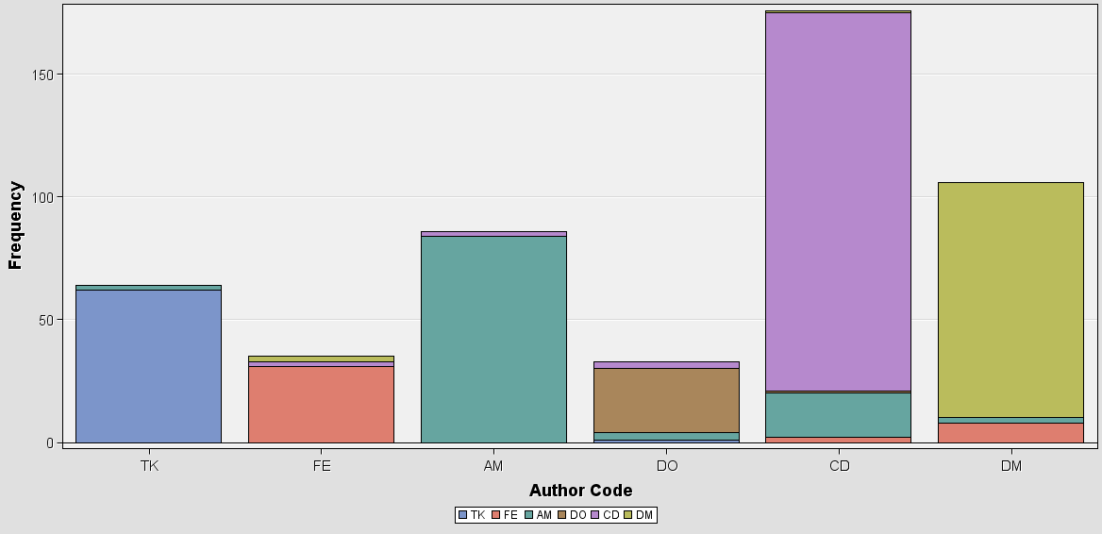

1. Record how many documents were classified correctly as belonging to the Unabomber. Estimate recall for TK (Unabomber) as # of correctly classified to the total number of documents, belonging to that author.

**62**